Q1 - Level: Simple

Topic: DISTINCT

Task: Create a list of all the different (distinct) replacement costs of the films.

Question: What's the lowest replacement cost?

A1 - select min(replacement_cost) from (select distinct replacement_cost from film) a

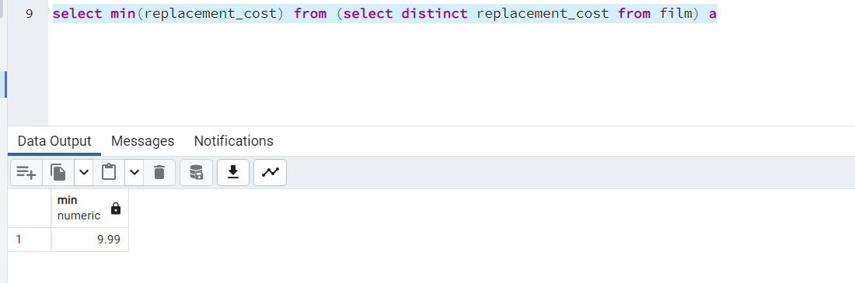

**Question 2:**

Level: Moderate

Topic: CASE + GROUP BY

Task: Write a query that gives an overview of how many films have replacements costs in the following cost ranges

1. low: 9.99 - 19.99
2. medium: 20.00 - 24.99
3. high: 25.00 - 29.99

Question: How many films have a replacement cost in the "low" group?

A2 - 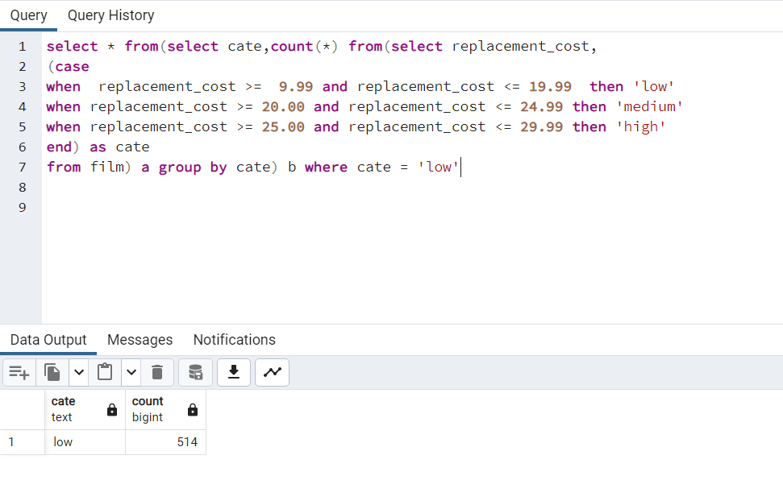

Q3 - Level: Moderate

Topic: JOIN

Task: Create a list of the film titles including their title, length, and category name ordered descendingly by length. Filter the results to only the movies in the category 'Drama' or 'Sports'.

Question: In which category is the longest film and how long is it?

A 3 - 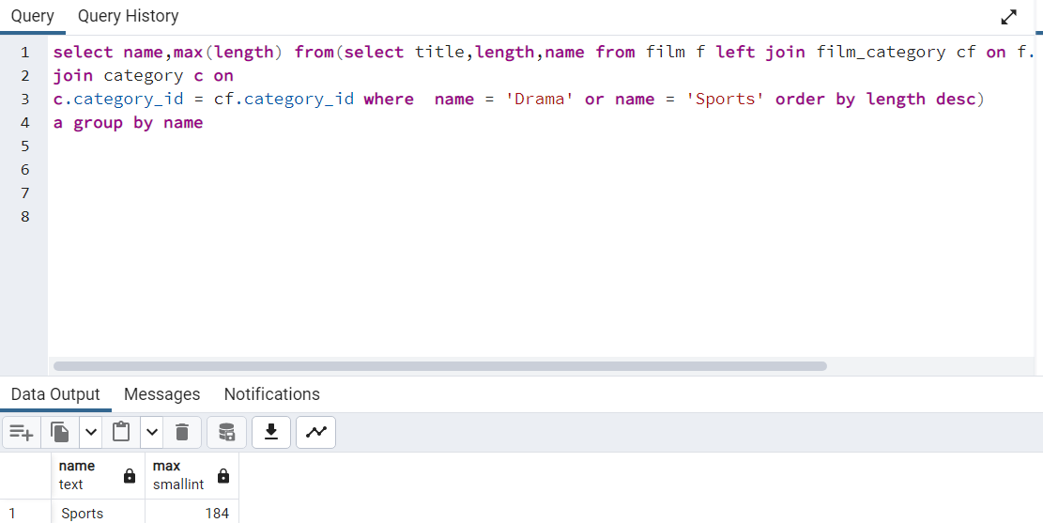

**Question 4:**

Level: Moderate

Topic: JOIN & GROUP BY

Task: Create an overview of how many movies (titles) there are in each category (name).

Question: Which category (name) is the most common among the films?

A 4 –

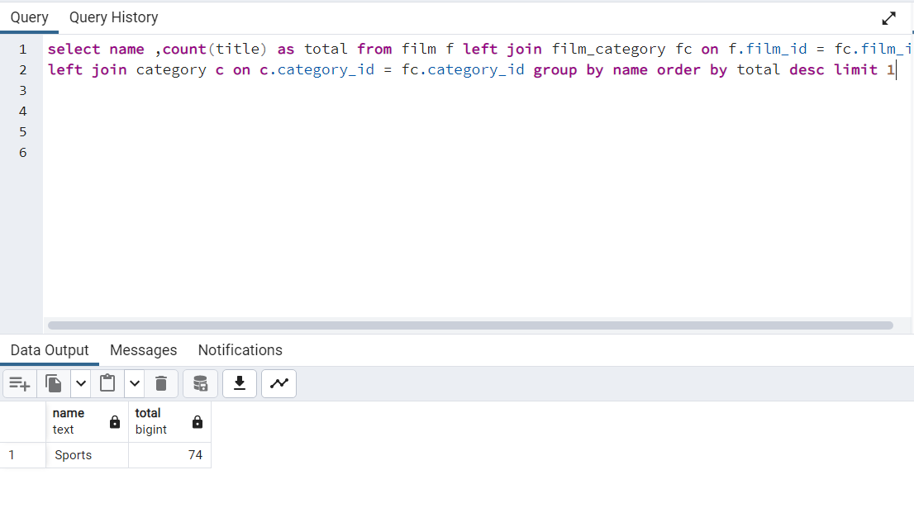

**Question 5:**

Level: Moderate

Topic: JOIN & GROUP BY

Task: Create an overview of the actors' first and last names and in how many movies they appear in.

Question: Which actor is part of most movies??

A5 –

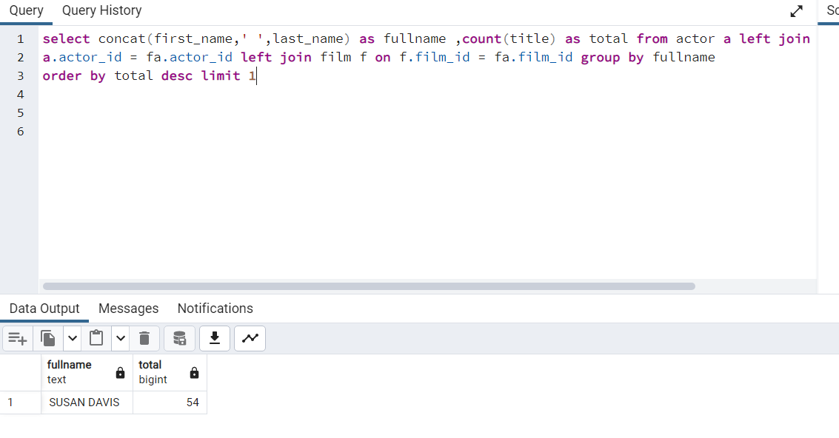

**Question 6:**

Level: Moderate

Topic: LEFT JOIN & FILTERING

Task: Create an overview of the addresses that are not associated to any customer.

Question: How many addresses are that?

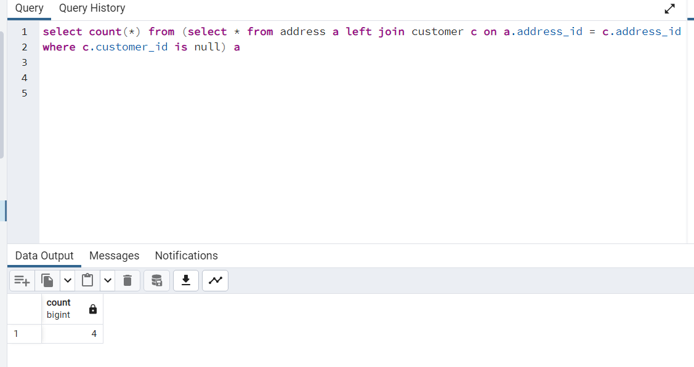

**Question 7:**

Level: Moderate

Topic: JOIN & GROUP BY

Task: Create an overview of the cities and how much sales (sum of amount) have occurred there.

Question: Which city has the most sales?

A – 7

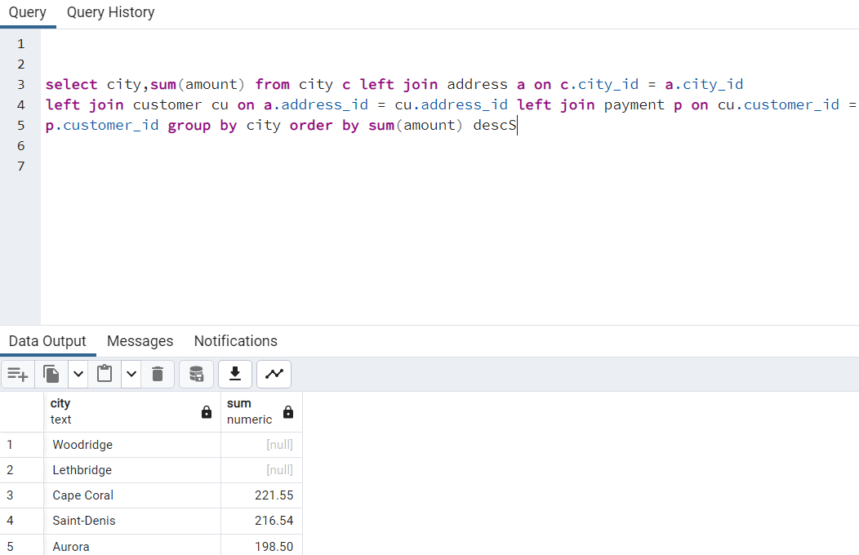

**Question 8:**

Level: Moderate to difficult

Topic: JOIN & GROUP BY

Task: Create an overview of the revenue (sum of amount) grouped by a column in the format "country, city".

Question: Which country, city has the least sales?

A 8 –

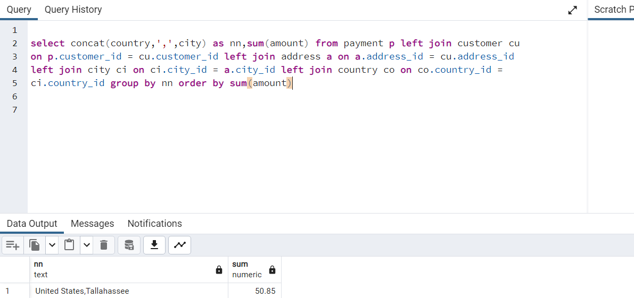

**Question 9:**

Level: Difficult

Topic: Uncorrelated subquery

Task: Create a list with the average of the sales amount each staff_id has per customer.

Question: Which staff_id makes on average more revenue per customer?

A 9

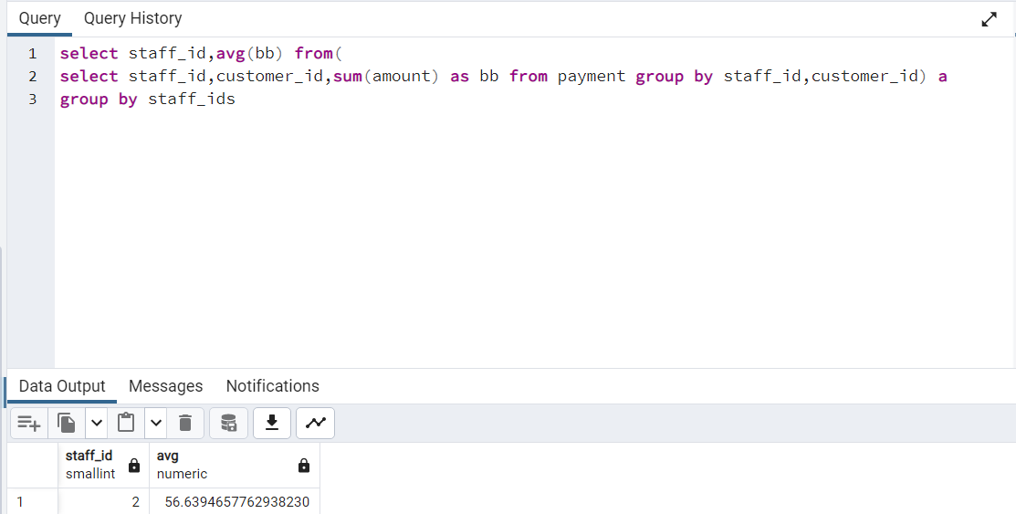

**Question 10:**

Level: Difficult to very difficult

Topic: EXTRACT + Uncorrelated subquery

Task: Create a query that shows average daily revenue of all Sundays.

Question: What is the daily average revenue of all Sundays?

A 10

